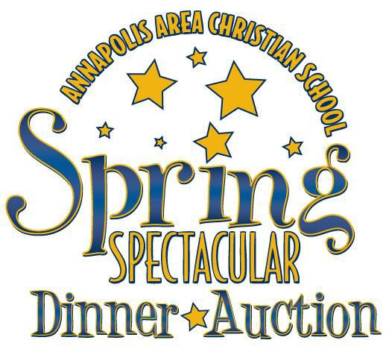
Saturday, April 13
Auction Donation Form

Please Fill Out & Return To:

Annapolis Area Christian School
2019 Spring Spectacular Auction
109 Burns Crossing Road, Severn, MD 21144
Email to akastendike@aacsonline.org or Fax: (410) 551-0907

Donor Information
Please print exactly as it is to appear on promotional material

Name:

Company Name (if applicable):

Address:

City: State: Zip Code:

Phone: Email:

Donation Information

Description of Item: (as you would like it to read in auction program)

Fair Market Value:

Conditions or Limitations:
(Examples: Service must be used within one year of auction. Vacations must specify times available.)

Delivery Options – Please check one: I will deliver item to AACS Upper School Campus
(109 Burns Crossing Road)
Please contact me to arrange pick-up

*Deadline for auction donations is Thursday, March 14.

Thank you for your generous support!
TERMS: Once donated, all items become the property of the AACS. Gift certificates must be good for a minimum of one year from the date of auction (April 13, 2019). Donor's failure to meet printed deadlines may result in limited publicity. AACS reserves the right to group items from various donors into bid packages. Stated value/availability of the donated item is the sole responsibility of the donor.
AACS is a tax-exempt 501c(3) organization. All contributions are deductible to the extent allowed by law.
Federal Tax ID #520936379

